Best Spiti Valley Tour Package from Delhi: Road Trip Plan, Hotel Stay & Travel Assistance
One of the most unique travel experiences you’ll ever have is to journey across India and especially through the Himalayas and Spiti Valley. You’ll have this feeling due to the variances in mountain terrains along your drive, seeing some of the oldest monasteries in this high desert region, and visiting virtually uninhabited rural towns! This is only the beginning of your adventure to Spiti. By selecting the best Spiti Valley packages from Delhi, you are granted access not only to all the incredible sights of this region but also enjoy these sights in ways that are safe, comfortable, and as visually stimulating as possible!
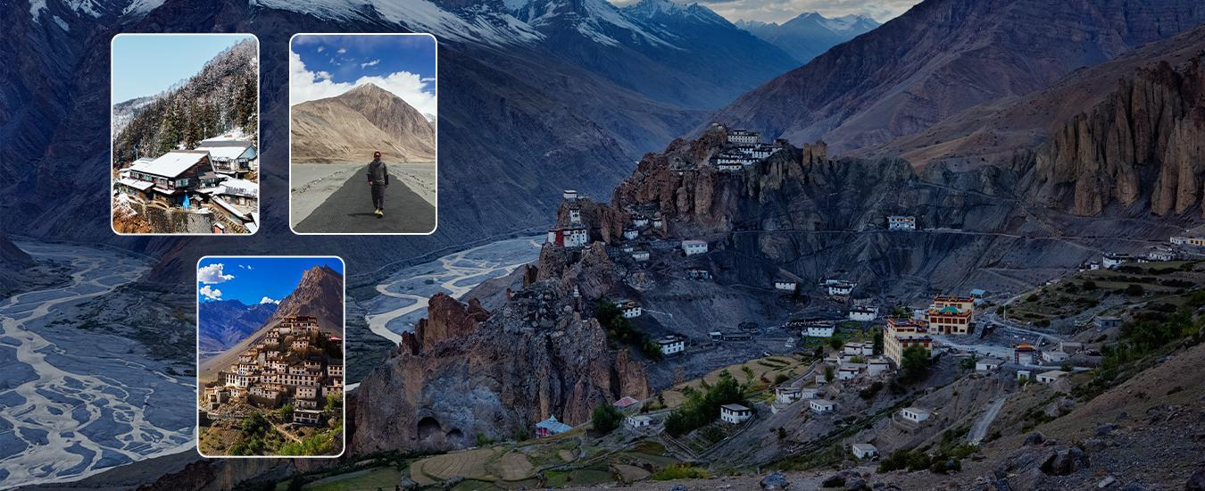

Why Choose Delhi to Spiti Valley Tour Packages?
The journey is the main focus of a Spiti road trip, not the destination. Unfortunately, many people fail to plan adequately for their trip, which may lead to feeling overwhelmed. Tour packages from Delhi to Spiti are designed to make it easy for you by providing all of the necessary information needed to create your own route, book accommodations, etc., allowing you to enjoy your trip without worrying about logistics.
All-inclusive Spiti Valley tours from Delhi will ensure that your journey through this beautiful area goes as smoothly as possible, allowing you to safely and comfortably travel through this challenging terrain.

The Ultimate Spiti Valley Road Trip Experience
The route to Spiti Valley is as superb as the actual destination. The majority of the tour packages available transport you through a planned route so you have an opportunity to acclimatise yourself to the higher altitudes.

Shimla Route - (The Best!)
Introduces you slowly into altitude as you travel to various locations through quaint towns, apple orchards and beautiful valleys.

Manali Route - (Adventure Style)
For those of you who have a thirst for adventure and adrenaline, it will put you into rugged terrain and the highest mountain passes available. Those of you who like the intensity of the journey will thoroughly enjoy this route.
Most of the best Spiti packages offer a combination of both routes, creating a full circuit.

What Makes Best Spiti Valley Tour Packages Special?
Because Spiti has not been created for tourism, meaning it is far away and still largely untouched or unspoiled compared to what you might expect due to its cultural richness, there are many different Spiti Valley tours available from which to choose. Here are some examples:
- Where you will stay (hand-picked by us) in places such as Kaza.
- Visits to key cultural sites (monasteries), such as Key Monastery.
- Access to remote/spiritual communities (villages) and culture; for example, you can visit Hikkim, Komic & Langza.
- At your convenience (ease) we will arrange transportation (assistance) in regard to altitude.
In addition, you will have ample opportunity to enjoy your experience (journey) without being rushed through it.

Stay Experience in Spiti Valley
Accommodation in the Spiti Region is about combining unique authenticity with comfort. Your Spiti Valley tour package will include:
- Your stay at a comfortable hotel with a view of the mountains; or
- A traditional homestay, where you will be welcomed and provided with local hospitality; or
- Taking part in a camping experience at beautiful camps located near Chandratal Lake.
They are not only for sleeping—but they are a major aspect of your trip's overall enjoyment!

Travel Assistance That Makes a Difference
What makes the Spiti valley tour worthwhile is the combination of its beauty and unpredictability. Roads, high altitude, and climate can change very quickly, resulting from many unknowns. Therefore, you need to have a properly put-together plan and the following components for easier management of your Spiti Valley tour operations:
- Skilled mountain drivers
- Local support
- Adequate acclimatization planning
- Support throughout your trip
All of the above support systems will relieve a lot of the burden, making your trip much more enjoyable.

Best Time to Plan Your Spiti Journey
When you travel to the Spiti Valley, you'll find timing to be one of the most deciding factors in your travel experience.
- Summer travel (May-June) has good road conditions and fine weather.
- Monsoon travel (July-September) allows for lush green views and dramatic scenery.
- Winter travel (for hardcore travelers) presents you with snowy winters that limit access.
Most of the more popular Spiti Valley tour packages are geared towards travel opportunities that will be safe and comfortable.

Why Spiti is More Than Just a Destination
An experience in Spiti will not be filled with luxury but rather with the natural beauty, stillness, and feeling of connection to the land. Whether you are stargazing in Kaza, visiting ancient monasteries, or just traveling along the limitless mountain vistas, each moment will feel dreamlike.
Choosing the right package for your trip to Spiti Valley from Delhi will provide you with these unfettered moments.

Final Thoughts
Taking a trip to Spiti Valley should not be done in an offhand manner — it requires careful planning. Having a well-designed Spiti Valley tour package allows you to achieve an excellent combination of the thrill of adventure along with comfort and direction provided by knowledgeable experts in this region of India.
If you are dreaming about taking a unique road trip through the Himalayas, a tour package designed from Delhi to Spiti Valley would give you the best opportunity to discover and explore this fascinating area.

Meta Title
Best Spiti Valley Tour Packages from Delhi | Travel O Sun
Meta Description
Explore the best Spiti valley tour packages from Delhi with scenic road trips, hotel stays & expert travel assistance. Plan your Spiti adventure today!

